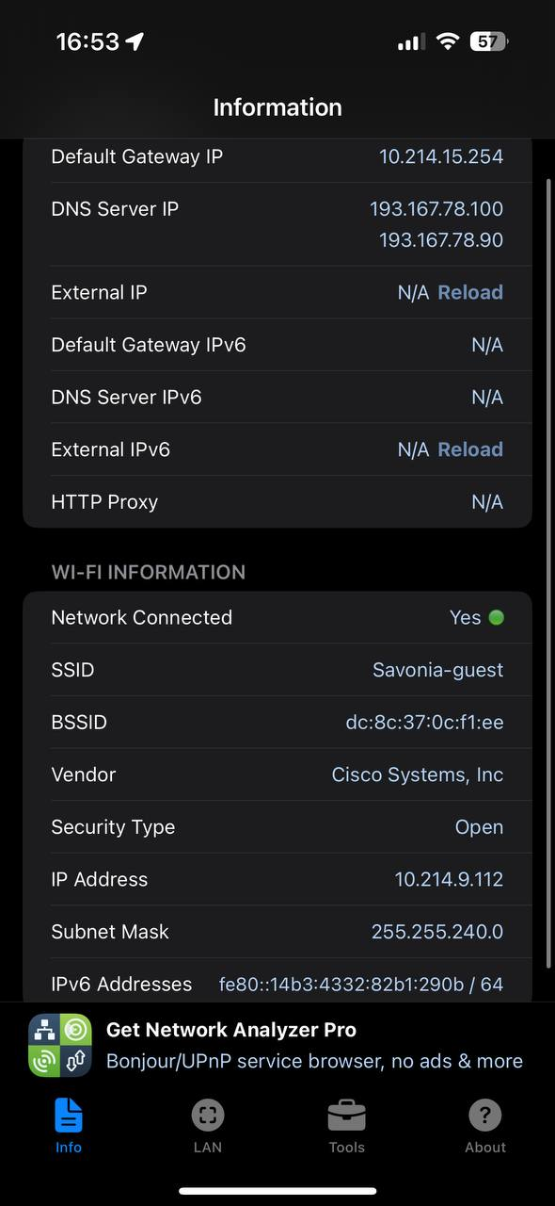
Wi-Fi Network Analysis – Wireless and Radiotechnology Course 2026
Objective
The objective of this task was to analyze a local Wi-Fi network and understand its configuration, performance parameters, and potential issues using the NET Analyzer mobile application.
Tool Used
- NET Analyzer (iOS)
Network Overview
- SSID: Savonia-guest
- Network Type: Wi-Fi
- Security Type: Open
- Vendor: Cisco Systems, Inc.
- Connection Status: Connected
Router and IP Information
Parameter | Value
IP Address | 10.214.9.112
Default Gateway | 10.214.15.254
Subnet Mask | 255.255.240.0
DNS Servers | 193.167.78.100, 193.167.78.90
IPv6 Address | fe80::14b3:4332:82b1:290b /64
BSSID (AP MAC) | dc:8c:37:0c:f1:ee
Observations
- The device is connected to an open guest Wi-Fi network, which may limit security and performance.
- The access point is manufactured by Cisco, indicating enterprise-grade infrastructure.
- A private IP address is assigned, typical for internal networks.
- IPv6 is partially available (link-local address).
Analysis and Potential Issues
- Open security may reduce protection and allow many users, increasing network load.
- Guest networks are often bandwidth-limited, which can affect speed and latency.
- High number of connected users can cause network congestion.
- Performance may degrade further away from the access point due to walls and floors.
Recommendations
- Use secured Wi-Fi (WPA2/WPA3) instead of open networks when possible.
- Connect to a 5 GHz band if available to reduce interference.
- Improve access point placement to reduce coverage gaps.
- Limit the number of devices on guest networks.
Conclusion
This Wi-Fi analysis demonstrated how network configuration, security type, and environment influence connectivity and performance. Open guest networks provide convenience but often suffer from congestion and reduced reliability. Proper security, channel management, and access point placement are essential for optimal Wi-Fi performance.

